Washington DC

________________
DC system size:10.0kW
Latitude/Longitude: 38.9, -77.0
tilt: 45º
roof pitch: 12/12
Azimuth: 186º
annual hours of full sun: 1818 hours
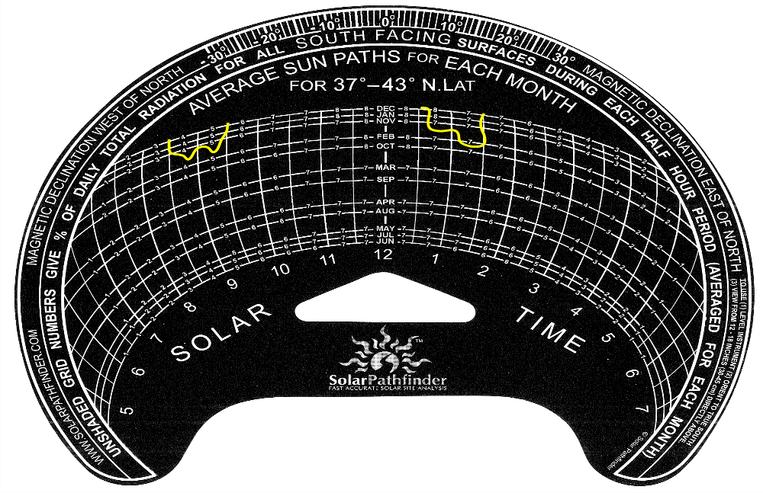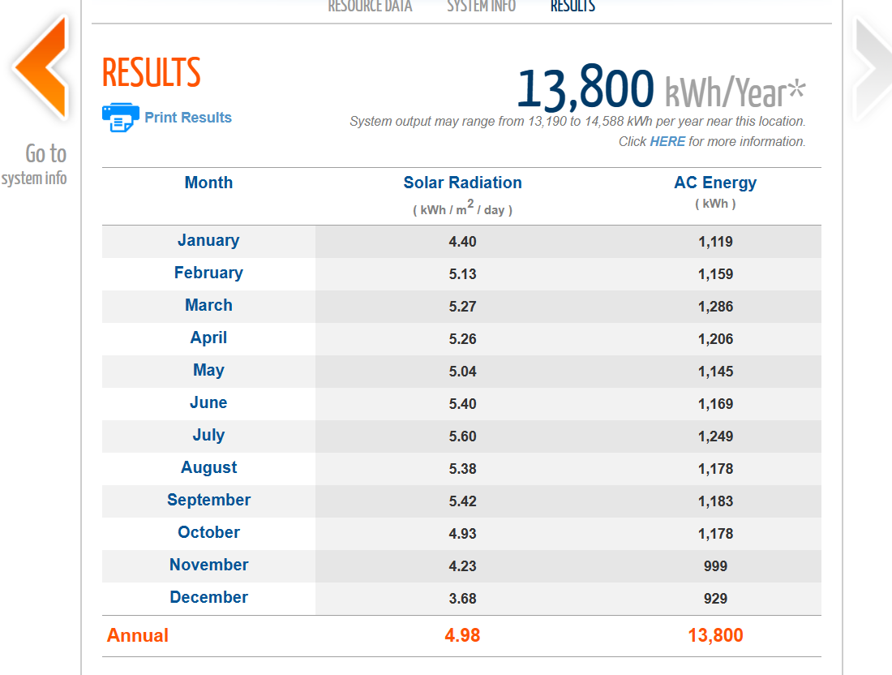

module : First Solar Series 6 FS-6430A
Data sheet:
https://www.firstsolar.com/-/media/First-Solar/Technical-Documents/Series-6-Datasheets/Series-6-Datasheet.ashx
Using the values you used from the datasheet:
- Pmp = 430 W
- Vmp = 182.6 V
- Voc = 219.2 V
- Isc = 2.54 A
- Temperature coefficient of Voc = -0.28%/°C
Derived:
- Imp = Pmp / Vmp
- Imp = 430 / 182.6 = 2.35 A

Inverter: Sunny Boy Smart Energy-US SBSE 4.8
Data sheet:
https://files.sma.de/downloads/SBSE-US-DS-en-23.pdf
SMA Sunny Boy Smart Energy-US SBSE 4.8
Given:
- Maximum inverter DC input voltage = 600 V
- Maximum inverter DC input power = 9600 Wp
Other inverter parameters such as MPPT voltage range, max input current, and max short-circuit current should also be checked against the final design.

Proposed System
- Target system size: 10.0 kW
- Proposed module count used in calculations: 18 modules
- Actual module layout proposed: 9 parallel strings × 2 modules in series (2S9P)
Note: This proposed layout does not equal 10.0 kWdc. It equals 7.74 kWdc.

expected 11740 KW to get 10000 KW due to efficiency of module.
Temperature Coefficient of VOC : -0.28%/°C
Lowest recorded T in DC in last 100 years : -25 C
Average high temperatures : 38 C

$$\frac{14,150}{4.98*365}=7.79 KW \\ \frac{sys power}{module}=18 module$$
Max input = 600 Volt
we will use 9 parallel 2 series modules
actual system power nameplate rating in kW = 7740 Wp
max inverter input = 9600 Wp
Proposed stringing
- 2 modules in series
- 9 strings in parallel
- Total modules = 2 × 9 = 18
Electrical rules
- In series, voltage adds and current stays the same
- In parallel, current adds and voltage stays the same

6.1 Module Electrical Values at STC
- Vmp,module = 182.6 V
- Voc,module = 219.2 V
- Imp,module = 2.35 A
- Isc,module = 2.54 A

6.2 String Values at STC
For 2 modules in series:
String Vmp
$$Vmp_{string}=2×182.6=365.2\text{ V}$$
String Voc
$$Voc_{string}=2×219.2=438.4\text{ V}$$
String Imp
Series connection does not increase current:
$$Imp_{string}=2.35\text{ A}$$
String Isc
Series connection does not increase short-circuit current:
$$Isc_{string}=2.54\text{ A}$$

6.3 Total Array Values at Inverter Input
For 9 strings in parallel:
Array Vmp
Voltage stays the same in parallel:
$$Vmp_{array}=365.2\text{ V}$$
Array Voc
Voltage stays the same in parallel:
$$Voc_{array}=438.4\text{ V}$$
Array Imp
Current adds in parallel:
$$Imp_{array}=9×2.35=21.15\text{ A}$$
Array Isc
Current adds in parallel:
$$Isc_{array}=9×2.54=22.86\text{ A}$$7.1 Cold Temperature Voc
Given
- Voc temperature coefficient = -0.28%/°C = -0.0028/°C
- STC reference temperature = 25°C
- Lowest recorded temperature = -25°C
Temperature difference
$$ΔT=-25-25=-50^{∘}C$$
Voc correction factor
$$1+(-0.0028)(-50)=1+0.14=1.14$$
Cold Voc per module
$$Voc_{cold,module}=219.2×1.14=249.9\text{ V}$$
Cold Voc per string
Since 2 modules are in series:
$$Voc_{cold,string}=2×249.9=499.8\text{ V}$$
Corrected cold voltage result
- Cold Voc per module = 249.9 V
- Cold Voc per 2-module string = 499.8 V
Inverter max voltage check
- Inverter max DC voltage = 600 V
- Calculated cold string Voc = 499.8 V
Result:
- PASS — below inverter maximum DC voltage

7.2 Warm Temperature Vmp
Given
- Average high temperature = 38°C
- STC reference temperature = 25°C
- Using the same voltage coefficient approximation you used
Temperature difference
$$ΔT=38-25=13^{∘}C$$
Vmp correction factor
$$1+(-0.0028)(13)=1-0.0364=0.9636$$
Warm Vmp per module
$$Vmp_{warm,module}=182.6×0.9636=175.95\text{ V}$$
Warm Vmp per string
$$Vmp_{warm,string}=2×175.95=351.9\text{ V}$$
Corrected warm voltage result
- Warm Vmp per module = 175.95 V
- Warm Vmp per string = 351.9 V
Inverter Compatibility Notes
Voltage
- Cold string Voc = 499.8 V
- Inverter max DC voltage = 600 V
- This appears acceptable
Power
- Array size = 7.74 kWdc
- Inverter max DC input power = 9.6 kW
- This appears acceptable
Additional checks still required
The following must still be verified from the inverter datasheet:
- MPPT operating voltage range
- Maximum input current
- Maximum short-circuit current
- Number of MPPT inputs
- Allowed parallel strings per input
This is important because:
- Array Imp = 21.15 A
- Array Isc = 22.86 A
These current values may or may not be acceptable depending on inverter input configuration.

Conclusion
The corrected design results for the proposed 2S9P, 18-module array are:
- Actual system size: 7.74 kWdc
- String Vmp: 365.2 V
- String Imp: 2.35 A
- String Isc: 2.54 A
- Array Imp at inverter: 21.15 A
- Array Isc at inverter: 22.86 A
- Cold string Voc: 499.8 V
- Warm string Vmp: 351.9 V
Overall findings
- Your original voltage calculations were off because you applied them to one module instead of the 2-module series string
- Your proposed 18-module array is 7.74 kWdc, not 10 kWdc
- The string cold voltage appears to be safely below the inverter’s 600 V DC limit
- Current and MPPT/input compatibility still need to be checked carefully against the inverter datasheet

